**Importance of API Development:**\* Topics to be Importance:  
1) What is API?  
2) What is Endpoint?  
 * baseURL  
 * resources  
 * parameters.  
3) HTTP methods – Idempotent methods and non -Idempotent methods  
4) HTTP status code  
5) Cookies.

1. What is API?

* API stands for application programming interface  
* It is an interface or communication protocol between a client and server intended to simplify the building of client-side software.  
* It has been described as a “contract” between the client and server.  
* It helps to independent software’s to communicate with each other.  
* Webservices – API communicates over internet over HTTP protocol that API known as webservices  
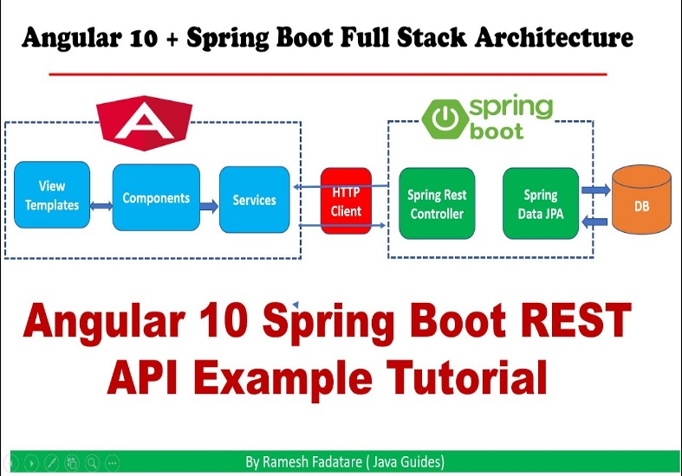 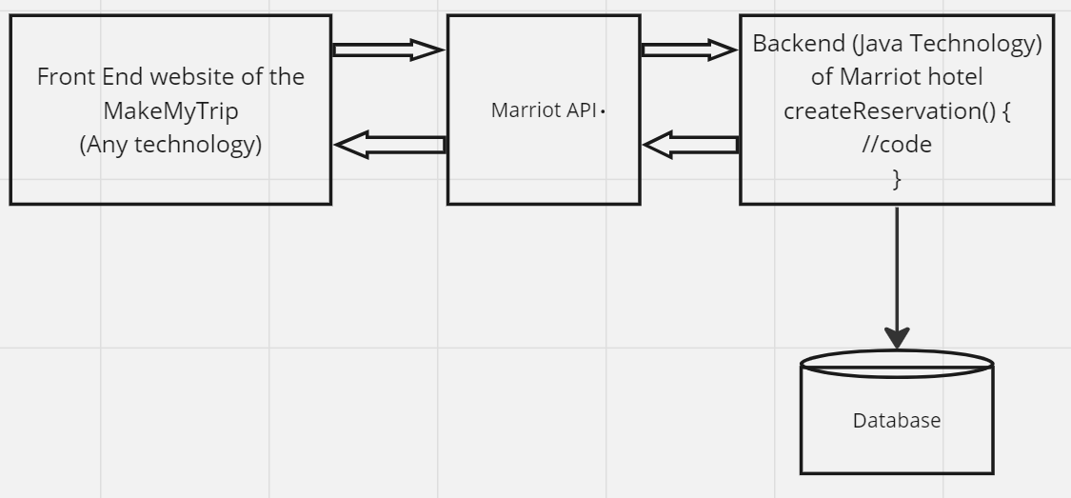

* API works as an interface between client and server.  
* In backend of Marriot hotel (Server) there is a methos called createReservation () through which reservation is getting created.  
* Developers can create an API which will call createReservation method and details will be sent to the Marriot hotel and reservation will be done.  
* Marriot hotel needs to expose the API the MakeMyTrip(client) will access the API.  
* API doesn’t have any code it works as transforming the information.  
* When client request for the reservation then Marriot API will call create reservation method as it is hosted in the same server.  
* Request is send over the HTTP protocol, and it is independent of any language.  
* When client shared data it is shared in a format that can be JSON or XML (Representation of data independent of all languages).  
* Once the reservation is done and Id will be generated and sent back to the API.  
* Frontend will parse the JSON/XML and extract the value. And on frontend it will show the reservation is confirmed and this is the reservation Id. Even MakeMyTrip also not require any code they just need to get confirmation.  
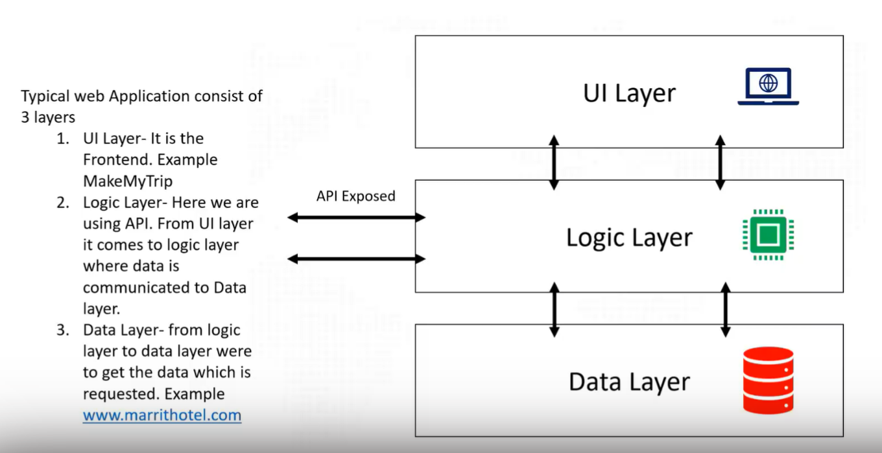

2) API testing:  
* API testing helps in validating the response coming to client. We can validate weather the functionality is working correctly or not.  
* Time efficiency. API testing doesn’t require GUI to be ready and it can be performed way early in the development cycle.  
* Less bugs-greater tests stability.  
* Return of investment will be high  
* Reduced cost  
* It is very closely connected with time efficiency  
* Ensuring user experience  
* Technology independent.

3) What does contract mean?  
-> It means, these are the prerequisites for testing the APIs  
* What is the base URL?  
 -> The BaseURL is an initial part of the API URL. Typically, all API requests to that API will use the same base URL.  
 Ex: https://www.google.com/  
  
* What is resource?  
 -> Resource represents an API or a collection which can be accessed from the server.  
 Ex: Google.com/maps  
 Google.com/images   
 Google.com/docs  
 Google.com/search  
 * Here the baseURL is google.com and resource is maps, images, docs, and search. Through this google understand to   
 which API is must direct the request which it has received.   
 * When we reach to the server to which API, we must be redirected that information is given by resource.   
   
* What is query parameter (Query/Path)?  
 -> 1) Path Parameter – These are the variable parts which keep on changing with every API request. They are typically used  
 to point specific resources within the collection.  
 Ex: <https://www.amazon.com/orders/1234>

2) Query Parameter – It is used to sort/filter the resources and identified by question mark (?)   
 Ex: <http://www.facebook.com/sharer.php?&t=FOOBAR&u=http%3A%2F%2Fwww.foobar.com%2F%3Ffirst%3D12%26sec%3D25%26position%3D>

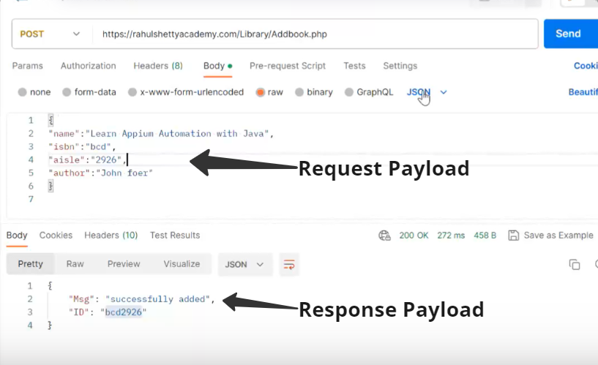 Endpoint: baseurl/resource/ (queryparam or pathparam)   
   
* What is the payload? And What is the expected response?  
 -> Payload means all the information which will have provided by the body

* What type of HTTP method used?  
 -> Idempotent methods – Idempotency means that sending the same request multiple times will produce the same result, without changing the state of the server or the resources. Safety means that sending a request will not change the state of the server or the resources at all, only retrieve information.  
 * GET: Retrieve the data from the server  
 * PUT: Send data to the server to update resources.  
 * DELETE: Delete resources from server.  
 -> non-Idempotent methods – as their outcomes may vary with each request.  
 * POST: Send data to the server to create a resources.  
 * PATCH: Send data to the server to update a resource partially.

4) HTTP status code  
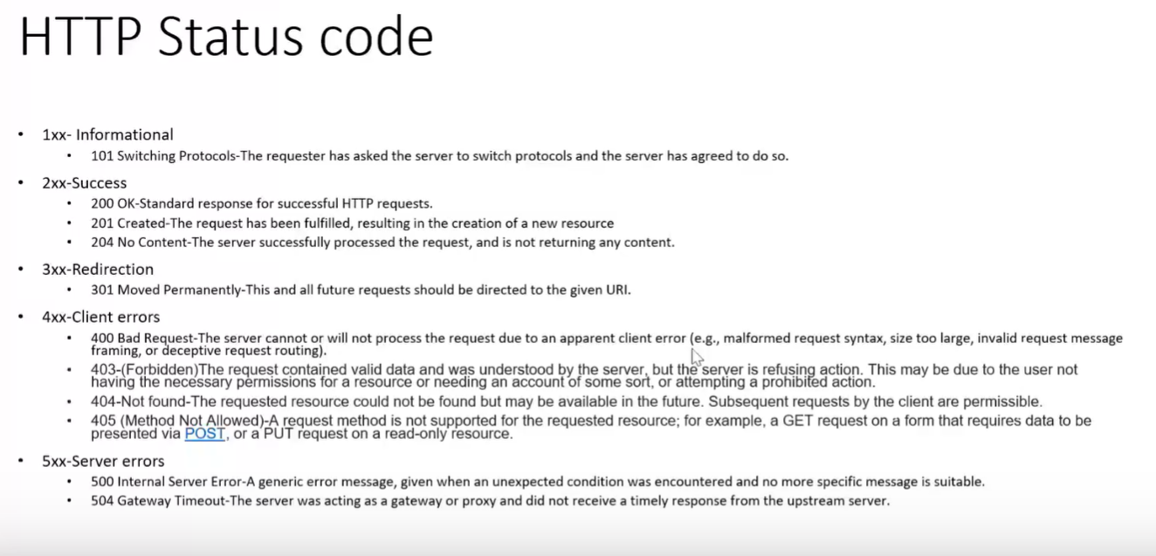

5) Cookies.

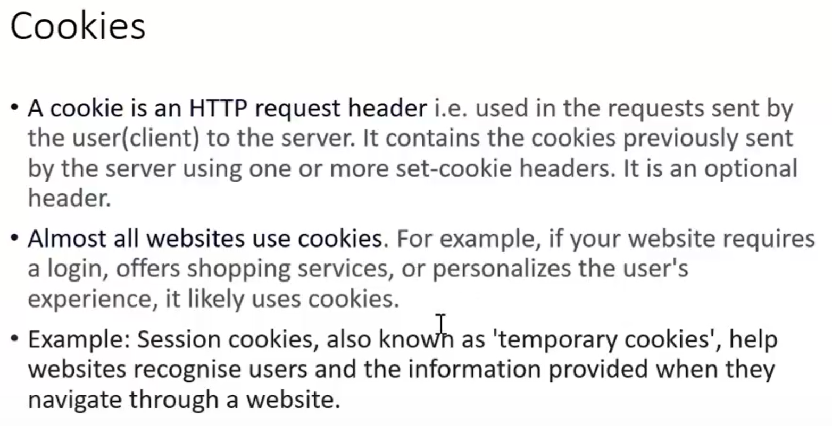

[Reqres - A hosted REST-API ready to respond to your AJAX requests](https://reqres.in/)

